Changing Timesheet Hours Denied to go through the Approval Process Again

If holiday or hours worked were denied by a supervisor, they can be changed by running the Update Time Administration Status and Earliest Change Data.

Update TA Status and ECD

Nav>Time and Labor>Process Time>Update TA Status and ECD

The Update TA Status and ECD search page displays.
- On the search page, enter the desired information into the Employee ID field.
- Select the Get Employees button. The search results will display.

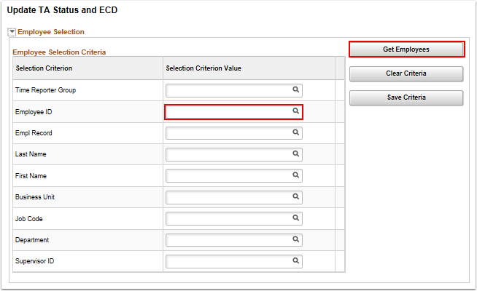

- There may be multiple Employee Records for the same EMPL ID.
- From the search results, locate the desired EMPL ID/EMPL RCD combination in the Time Reporters section.
- The Earliest Change Date (ECD) and TA Status are used by the Time Administration process to determine if an employee is up for processing or not.

In this case, there are two Empl Records and they are not up for processing so I need to change that.

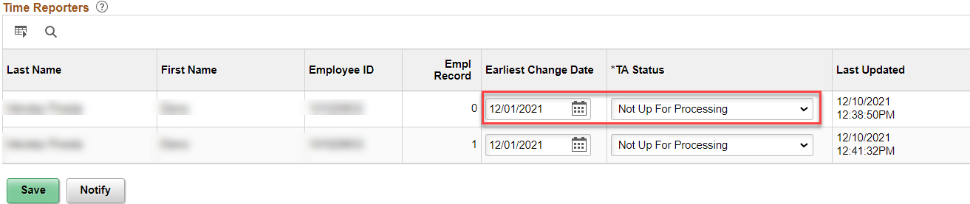

- The ECD determines the date from which to process; select an ECD of the 1st or the 16th of a specific month.
- The TA Status determines if the employee is:
  - Up for Processing (just what is means…up for processing to the supervisor)
  - Not Up for Processing (nothing going to happen at this time)
  - In Process (yep, in the process of being processed)
- Select the TA Status for the employee.

I know it is Empl Record 0 and the Earliest Change Date (time needing approved) is 11/16/21. Change TA Status to “Up For Processing”, Save.

NOTE: If there is a holiday on the first day of one pay period, put the earliest change date back to the last working day in the previous pay period.

- Select the Save button.
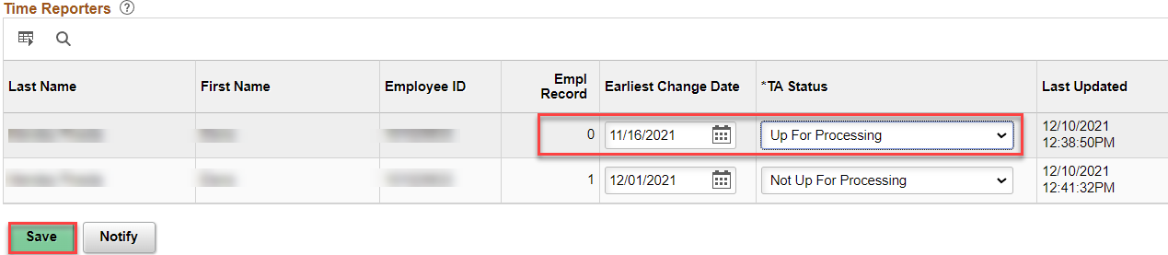
- The process to Update the TA status and the ECD are now complete.
- End of procedure.

To send to the supervisor right away, go to Time & Labor Processing and Request Time Administration (Run Time Admin).

That’s it!

