Search/Match (including issues that arise)

SOMETIMES THE PERSON IS IN THE SYSTEM BUT YOU STILL CANNOT ADD THEM AS A NEW EMPLOYEE INSTANCE OR CANNOT FIND THEM IN MODIFY A PERSON. SEE BELOW FOR SOME WAYS AROUND THIS.

Perform a Search/Match: Nav > Workforce Administration > Personal Information > Search Match Internal/External
- The Search/Match Integrated search page displays.
- In the Search Type drop-down menu, select Person.
- In the Search Parameter lookup field, select PSCS_TRADTIONAL.
- Select the Search button.

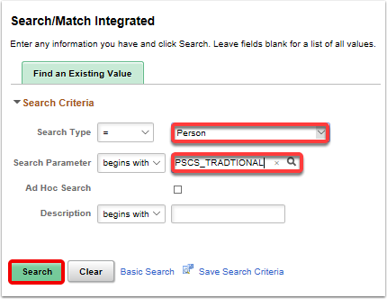

- The Search Criteria page displays.
- In the Search Result Code lookup field, select the PSCS_TRAD_RESUL option.

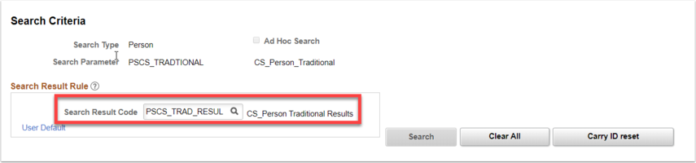

- Enter values for the following fields: MAKE SURE YOU TAB OUT OF THE FIELD
  - First Name Search
  - Last Name Search
  - National ID
  - Note: You can search by entering the First Name and Last Name only OR the National ID only, but it is best to enter at least 2 Search Values in order to activate the Search button.
- Select the Search button.

Based on your Results you will have two options: A or B THERE MAY BE OTHER ISSUES SO SEE BELOW FOR A FIX

A: If a potential match is not found a Message box will appear stating that your Search Criteria did not return any results.
- Select the OK button. Search Match is complete.
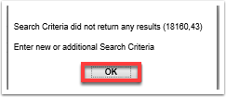

- Navigate to the Add A Person page to begin new hire process. Refer to QRG titled Adding a New Employee and a Job Instance .

B: If a potential match is found the Search Results Page will appear.
- Select the Results 2 tab to verify the National ID (SSN).
- Copy the Empl ID (copy with cursor or manually record on paper).
- Select Return to Search Criteria.
- Search Match is complete.
- Navigate to the Add A Person page to begin new hire process.

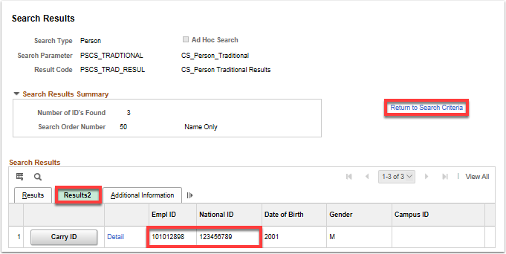

You might see Import and or Carry ID. Try Import to see if it works (Carry ID does not work as of 9/26/21). If Import does not work go to Add Employment Instance and try to add an Employment instance.

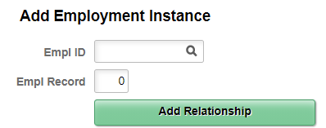

If you had problems with Adding a Person or Modify a Person but were able to add an employment instance, be sure to go to Modify a Person and make sure the information is correct.

If you cannot Add a Job Instance, go to Add a Person

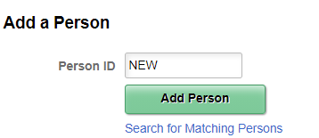

IF YOU HAVE AN EMPL ID, instead of clicking on Add Person (NEW), put in the Empl ID and click Add Person.

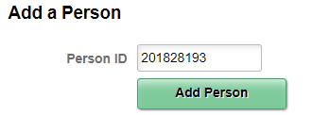

If none of this works, put in a ticket.

That’s it!

