View, Download, Print W-2 Form for an Employee (the QRG is great!)

Nav>Payroll for North America>US Annual Processing>Create W-2 Data>View W-2/W-2C Forms

- The View W-2/W-2c Forms search page displays.
- Enter the Empl ID (or Name).

- Select the Search button.

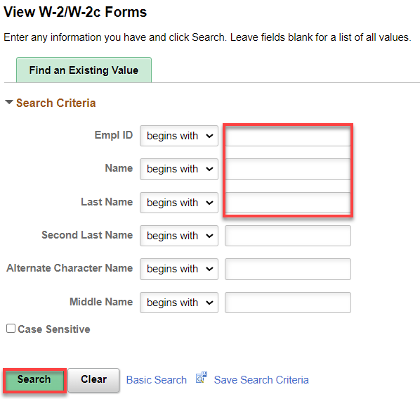

- The View W-2/W-2c Forms page displays.
- The forms for the most recent tax year will display. To view other years, select View a Different Tax Year.

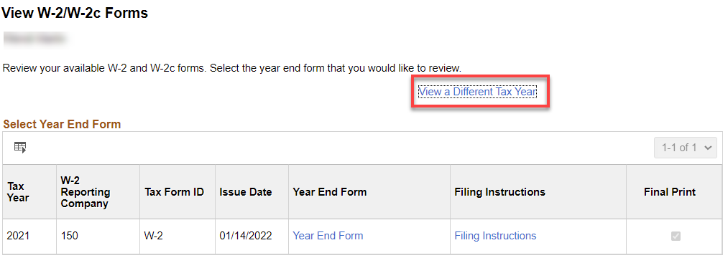

- The Tax Year list displays.
- Select the desired year from the list.
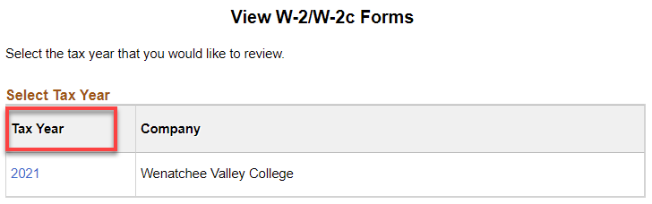

- From the list of Tax Form IDs, select the Year End Form that you wish to view.
- Select Filing Instructions for the appropriate tax form to view the filing instructions.

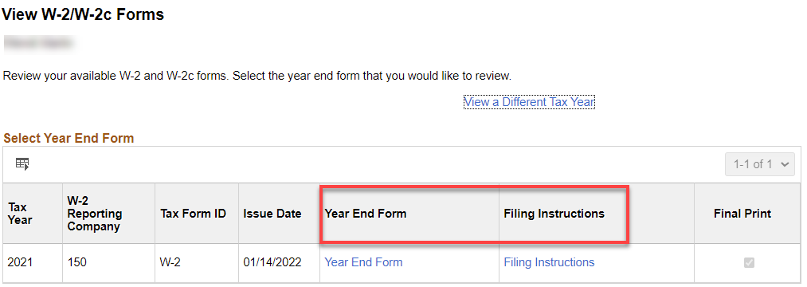

- The respective PDF document will open and could be downloaded and/or printed.
- The process to view, download and print W-2/W-2c Forms is now complete.

That’s it!

