Requesting Preferred Name in Employee Self Service

Preferred Name Request

This action will initiate a change, human resources (HR) will approve and make final changes in ctcLink.

Nav: Employee Self Service>Personal Details tile>Name tile

- In Employee Self Service, select the Personal Details tile.
- Select the Name tile.

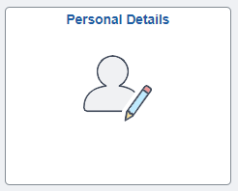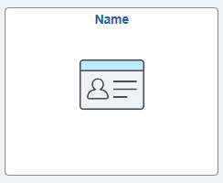

- On the Name page, select the arrow to the right of the Current Name, to open the Name page.
- On the Name page, the Change As Of date field defaults to the current date. Change date as appropriate.
- Select the Preferred First Name field and enter the Preferred First Name.
- Select the Preferred Last Name field and enter the Preferred Last Name (or leave default last name if no change is needed).
- The Display Name, Formal Name and Name fields update to reflect the names entered.
- NOTE: If you have attachments related to this transaction, you can upload them by selecting the Add Attachment button.
- Select Save.

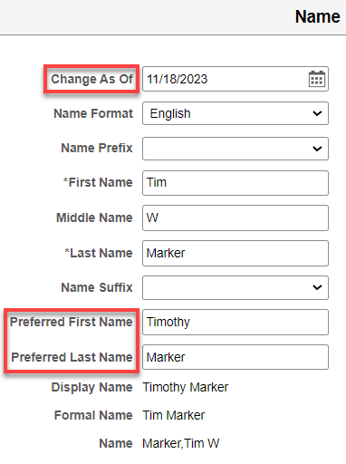
- The request has now been successfully sent to HR for approval and processing.

Note: Once HR approves the request, they will make the change. The change will not be made in payroll or tax-related documents. It will be shown in Employee Self Service, Absence Management, Time & Labor, and Job Data. If you want your preferred name in Campus Solutions (CS) and Canvas, please email human resources and we will make the additional name change.

That’s it!

