Short Work Break

For temporary or cyclic employees, including hourly, student and volunteers, that you know will be returning, put them on a Short Work Break.

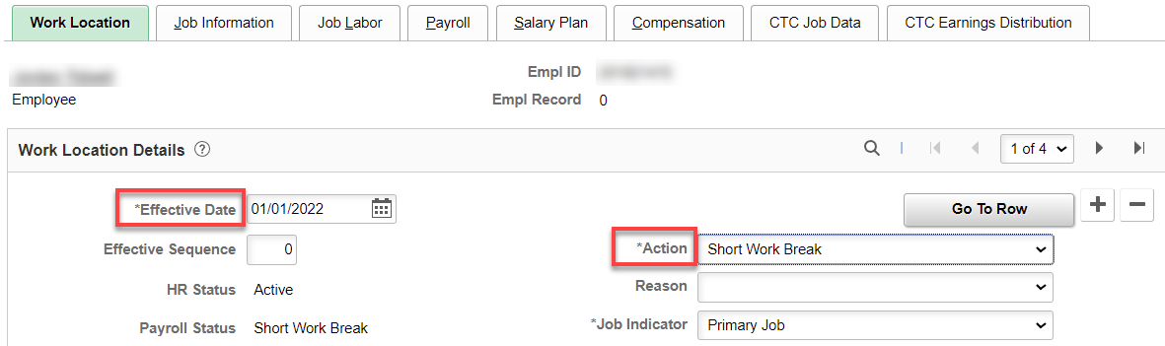

To bring them out of a Short Work Break, just add + a row, add the Effective Date and under Action, select Return from Short Work Break.

That’s it!

