Promotion from Classified to Classified

Job Data

Work Location tab: Add + a Row, change Effective Date to the new job date, add Action (Transfer), Reason (Promotion), new Position Number (the rest of the data will change based on the position number), click Override Position Data, change department (if necessary-it should be correct if the position number has the correct data behind it). If there is an overlap in the person leaving and the new person starting the job, you will get a warning. Just click OK (it is alright to overlap people with the same position number).

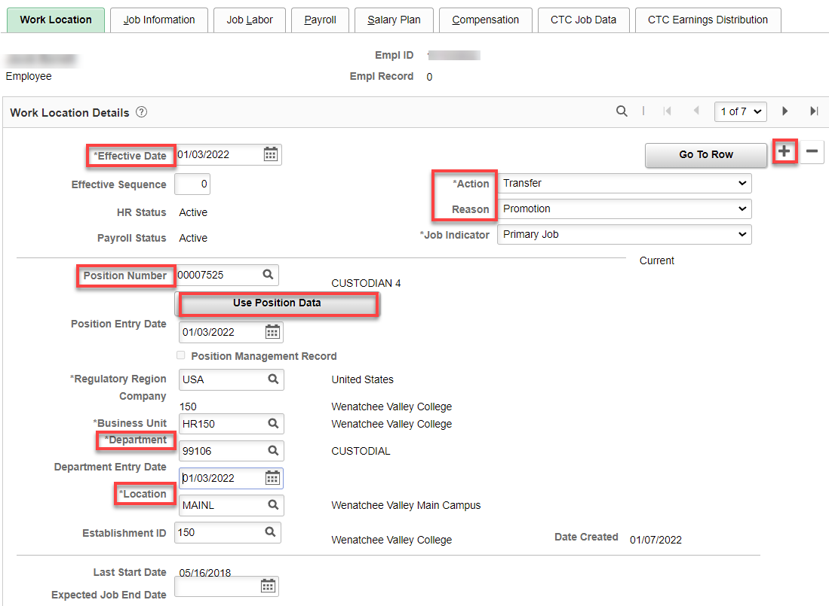

Job Information tab: Change Supervisor ID (if needed), Empl Class (Classified), Regular Shift (if paid shift differential, choose Evening), Work Period (W522), check FTE (should be 1.00 if FT) – If Position Data still has W for Workweek (which pulls from Position Management which pulls from Job Code), you will have to change it to W522, which changes the FTE so it has to be changed back to 1.00.

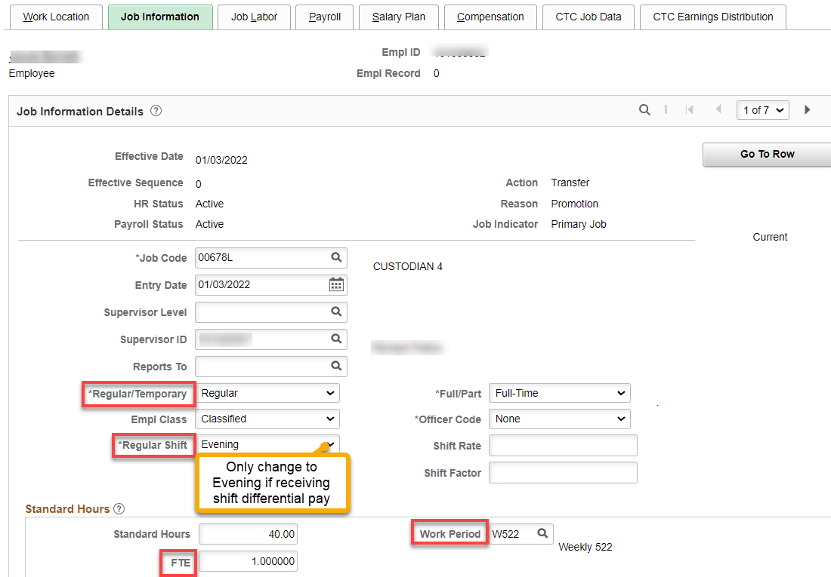

Job Labor tab: Union Code and Union Seniority Date should not change.

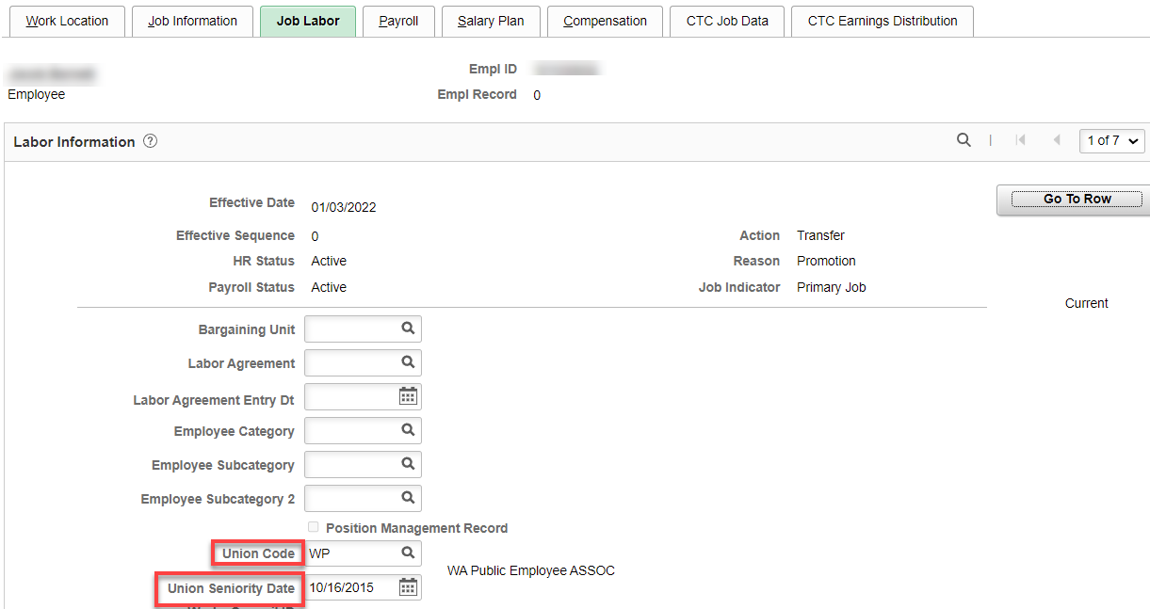

Payroll tab: Nothing should change

Salary Plan tab: All you should need to enter is Step and change Step Entry Date back to the prior job Step Entry Date (click on the next row to see the date).

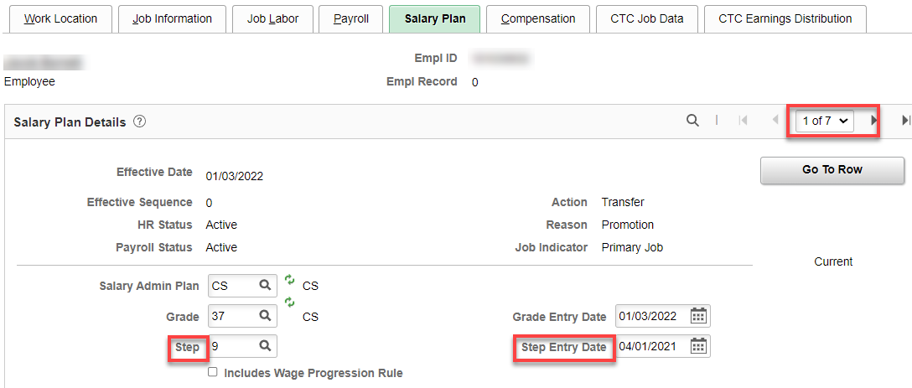

Compensation tab: Enter new annual salary and hit Calculate Compensation, click on Pay Rates and double check monthly rate.

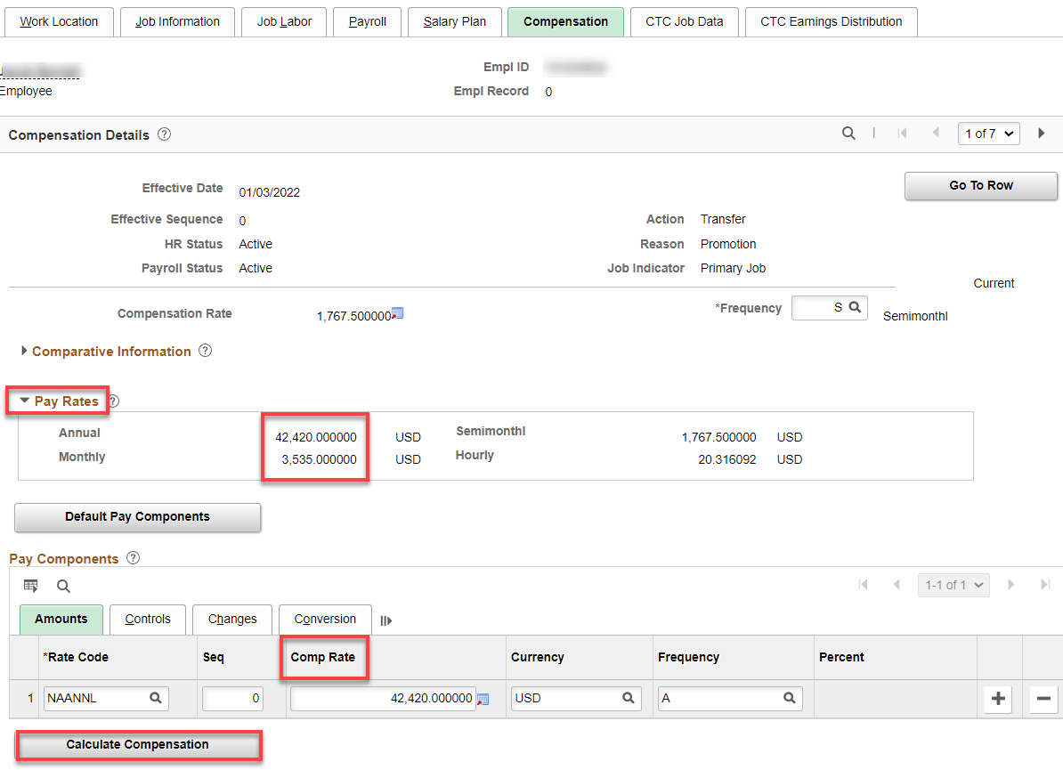

CTC Job Data tab: Add Trial Service Date, everything else should be the same as before but check things like Job Term (if less than 12), Job Emp Type, Union Member check box and OFM Bargaining Unit (in case the new job changes anything). DRS Calendar Code is not needed.

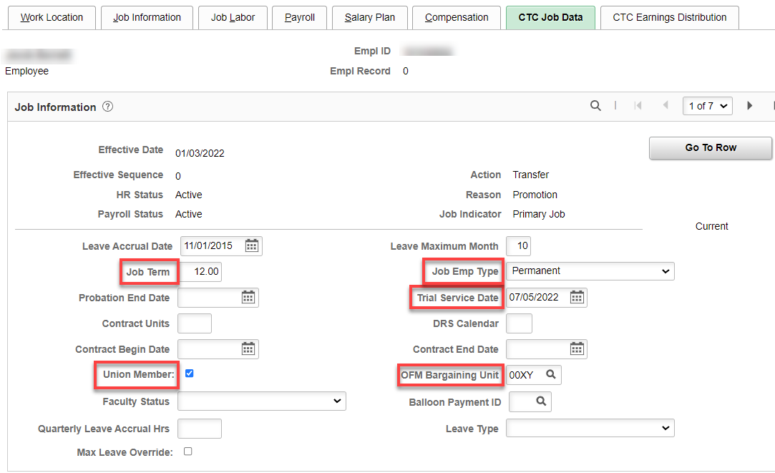

CTC Earnings Distribution tab: Enter new Combination Code(s), Save.

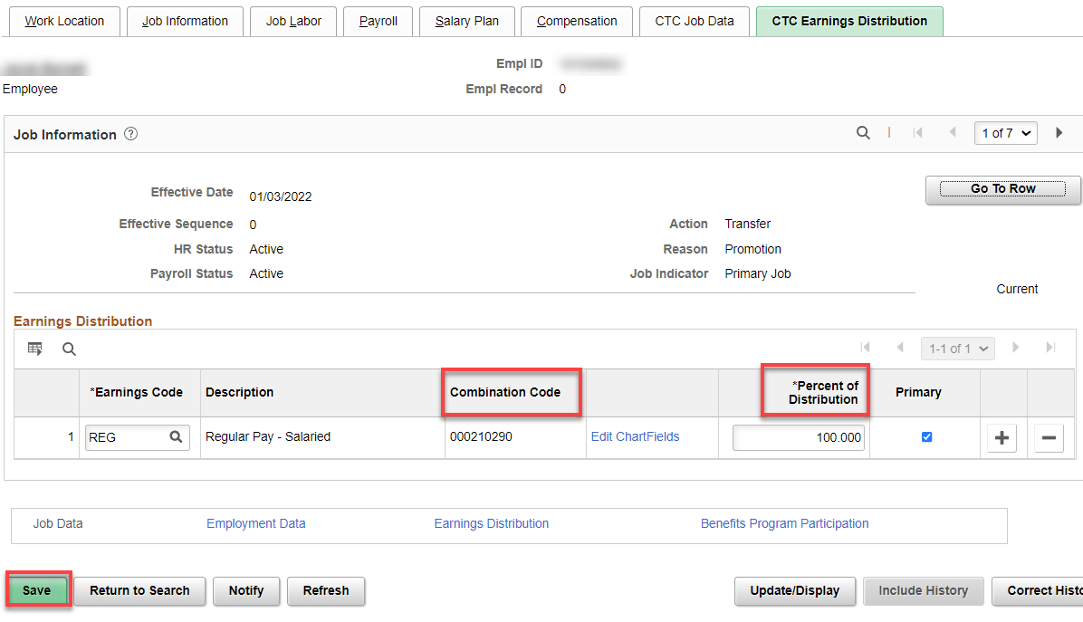

Click Employment Data – no change

Benefit Program Participation – no change

Retirement Program – no change

Work Schedule? Change if needed.

That’s it!

