Entering a Pay Increase (adjustment, retention, promotion, etc.) QRG is pretty good.

Entering a Pay Increase Using Comp Rate Codes

Nav>Navigator>Workforce Administration>Job Information>Job Data

- The Job Data search page displays.
- Enter the Empl ID in the Empl ID field.
- Select the Search button.
- Select the appropriate Empl Record from the Search Results section.
- The Job Data page displays.
- The Work Location page contains information about an employee’s job, such as position, regulatory region, company, department and location. Information on this page reflects the last action for this employee.
- Select the Add a Row button to record a pay rate change.
- Enter the new Effective Date in the Effective Date field. The system will default to today’s date, modify if needed.
- Select Pay Rate Change from the Action drop-down menu.
- Select Adjustment, promotion or whatever the reason from the Reason drop-down menu.

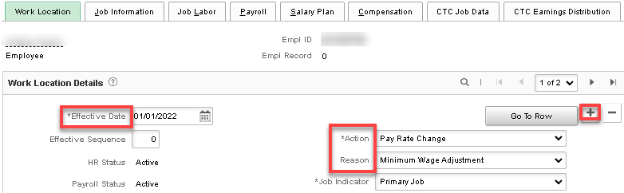

- Select the Compensation tab.
- The Compensation page displays. Use the Compensation page to specify the compensation rate for an employee.
- Select the appropriate Rate Code. NAANNL and NAHRLY are currently the only options used.
- Enter the new pay rate in the Comp Rate field. SEE BELOW
- Select the Calculate Compensation button.
- Select the Save button.
- The process to enter pay increases using comp rate codes is now complete.
- End of procedure.

Enter annual salary if FT 12 month, leave the Frequency at S and hit Calculate Compensation.

If less than full year, salary must be calculated by daily rate. Calculate salary for the days worked until the change in salary, then check salary already paid. If there is a difference, it must be added or subtracted as a PSHUP file. In this example, the rate already paid was $126.434 short of what was owed so that amount is paid through PSHUP file. Calculate the salary for the rest of the appointment period, enter prorated salary and change the Frequency from “S” to the number of payments left in the appointment period.

Example in this case: $60,009/261= $254.908045 x 44 days = $11,127.95376 (amount earned) minus $11,001.52 (amount paid) = $126.434 difference to be paid through PSHUP file. New rate: $72,000/261x 217 days left in appointment period = $59,862.069 with the number of pay periods left = 20 (C20).

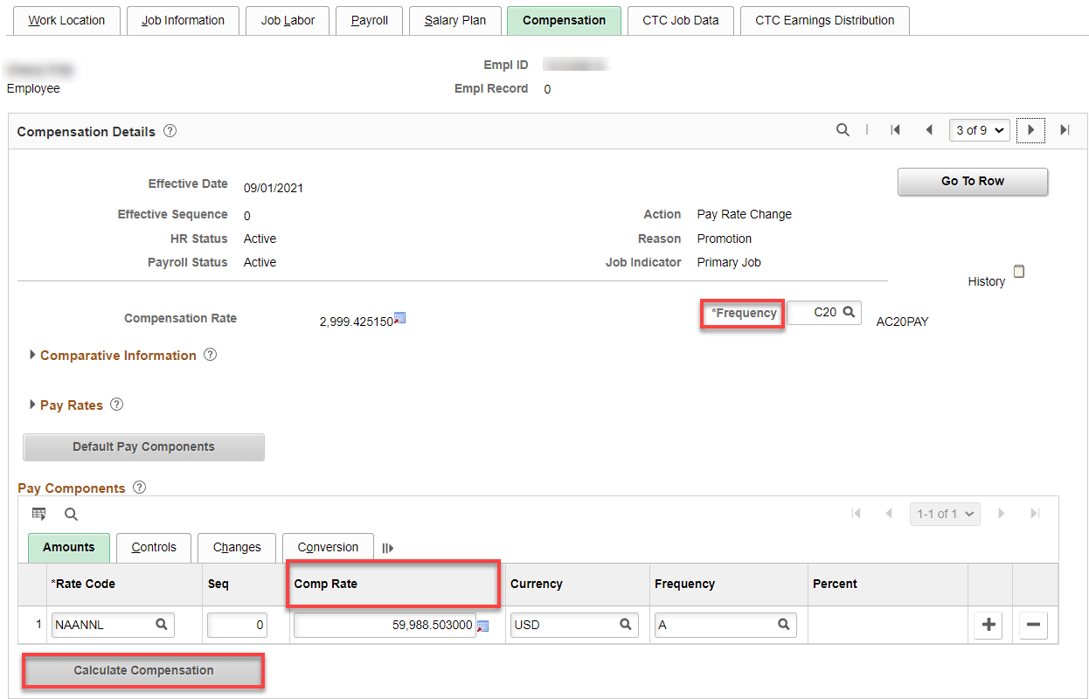

CTC Job Data tab: The QRG doesn’t say anything about changing this page so either leave it or change the Contract Units and Contract Dates (I left this one alone).

CTC Earning tab: change Combo Code and Percent of Distribution, if needed. Save.

That’s it!

