Exempt Contract Date Change for New Fiscal Year

There is no automated process for a mass change of all exempt contract begin and end dates.

Job Data
Work Location tab: Add + a row, change Effective Date to 7/1, Action (Data Change), Reason (Contract), change Effective Sequence if there is already a 7/1 Effective Date.

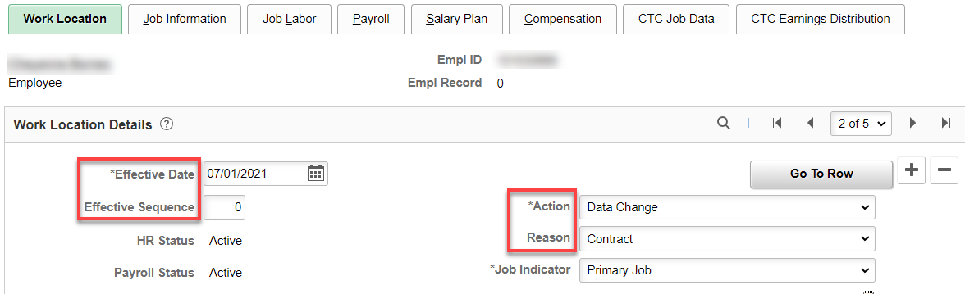

CTC Job Data tab: Change Contract Begin Date and Contract End Date, and Contract Units, if not 261, Save.

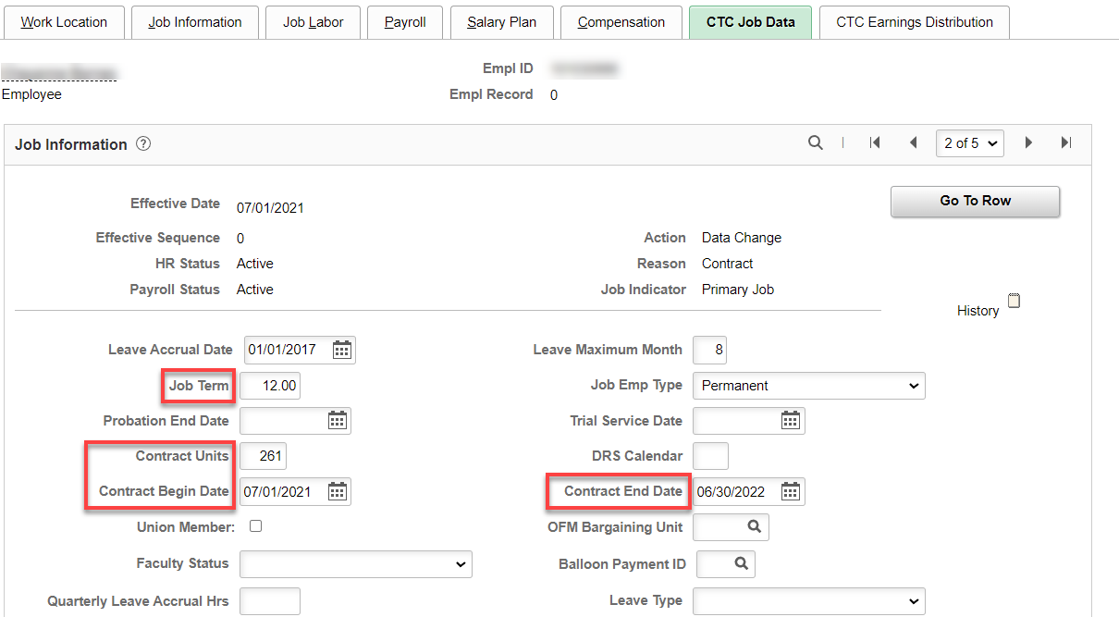

Be sure to check Compensation to make sure it is correct, especially for those that didn’t work a full year.

Run CTC_JOB_DATA or QHC_HR_CTC_JOB_DATA query to get a list of exempt and their salaries and compare to exempt salary spreadsheet (I’m sure everyone has one, right?).

That’s it!

