Change in Percent of Assignment - Classified
Job Data
Work Location tab: Add + row, change the Effective Date, Add Action (Data Change), Reason (Status Change).

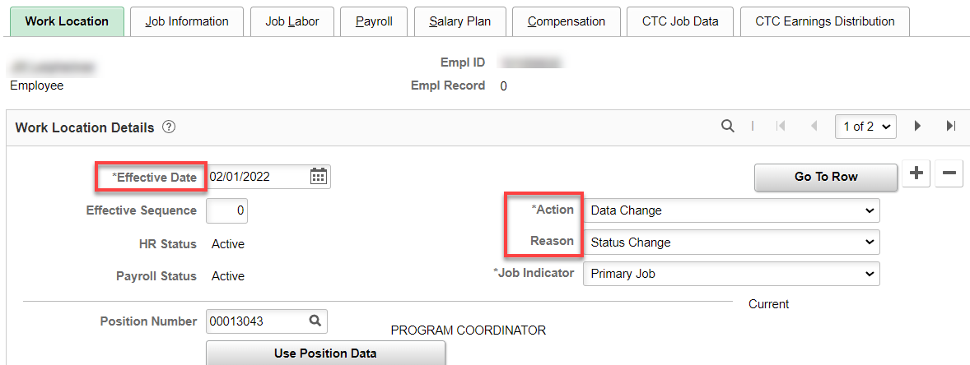

Job Information tab: change Standard Hours and FTE. Refresh and change FTE back to what it should be, if necessary.

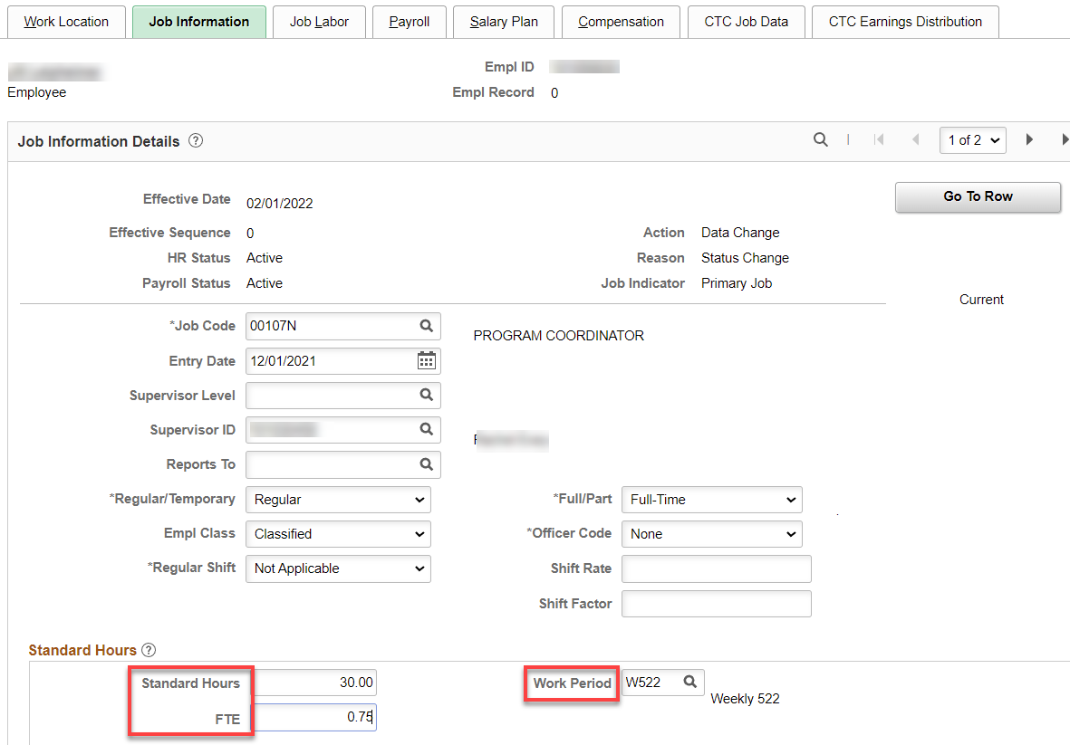

Job Labor tab: shouldn’t be any changes.

Payroll tab: should be the same if it is classified to classified.

Salary Plan tab: nothing to change.

Compensation tab: Multiply the FT rate by the FTE, enter new Comp Rate, leave the Frequency at S and hit Calculate, Save.

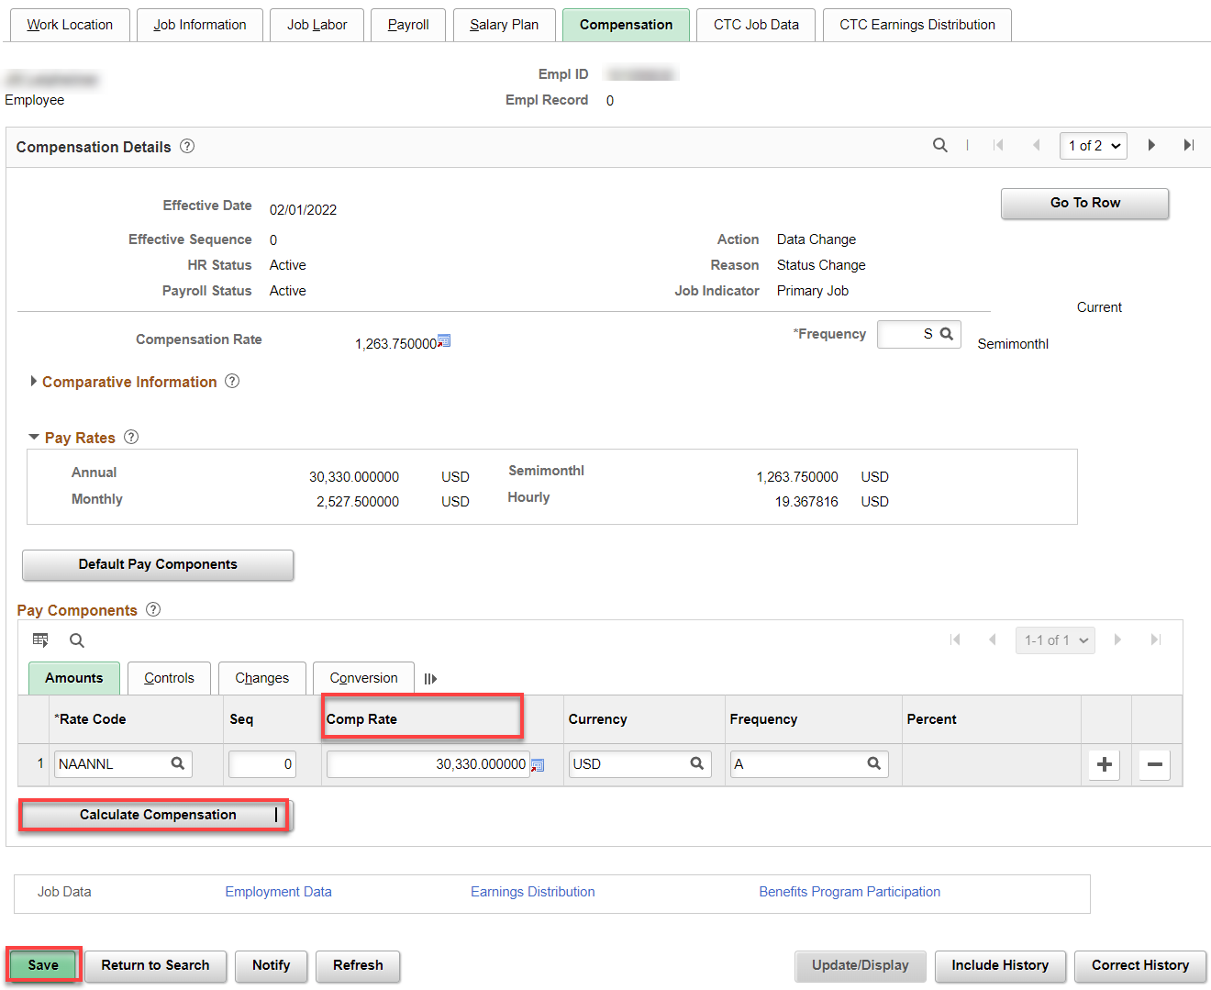

Employment Information tab: should be the same.

Time and Labor Data: should not change.

Benefit Program Participation link: no change

Benefits should be the same so no need to go there.

That’s it.

