Add A New Employee Instance

Nav>Workforce Administration>Job Information>Add Employment Instance

Add or Convert a Classified Part Time Nonpermanent

Work Location tab: Put start date as effective date, If new hire, add Company and Department, press tab and the rest will autofill (double check it though).

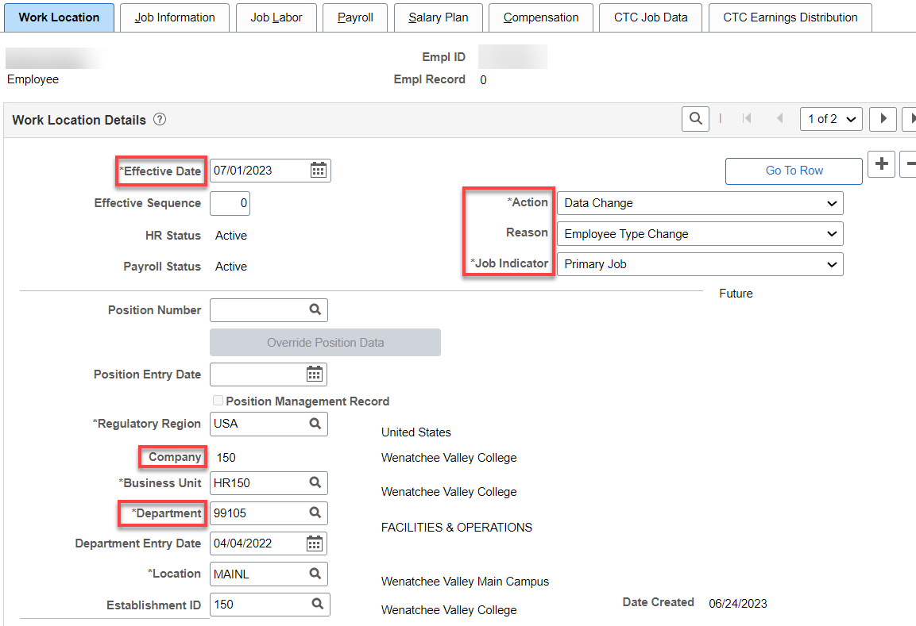

Job Information tab: Put in classified OFM Job Code, Supervisor ID, Temporary, Part Time, Empl Class (Classified), Standard Hours should be 40 (system will pay from timesheet), Work Period should be W522, FTE 1.00 (This is important so leave accrues properly). Always double-check FTE to make sure it remains 1.00 after Work Period update. IF ELIGIBLE FOR SHIFT PREMIUM PAY, put Evening in Regular Shift.

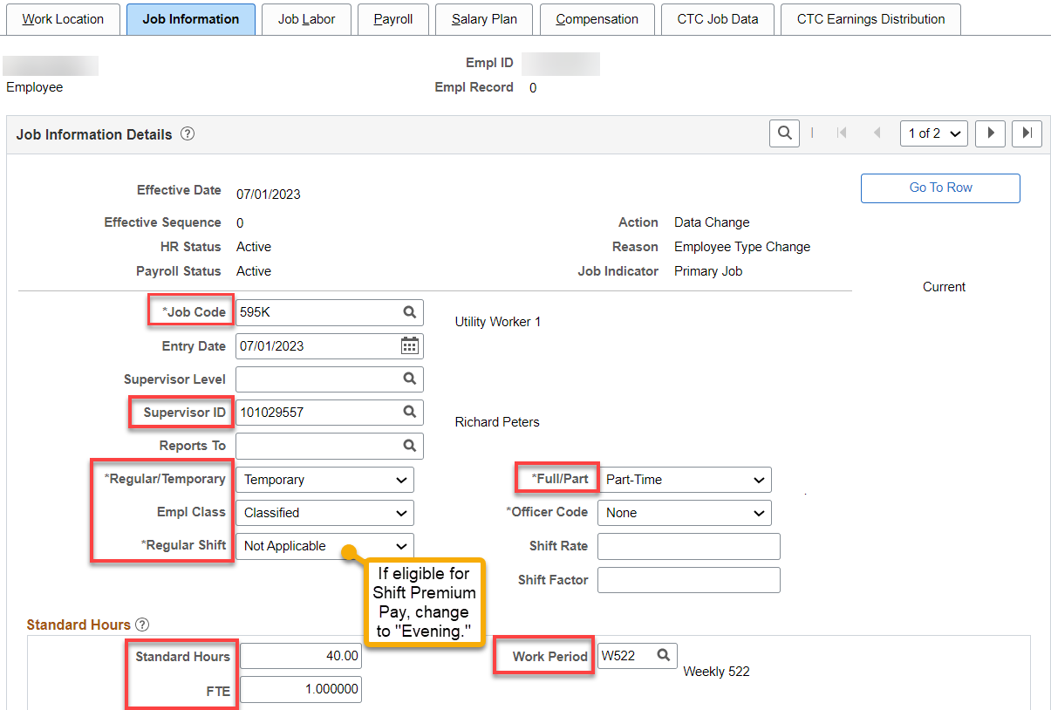

Job Labor tab: The union code should already be applied (pulls from the job class), change if needed. No need for Union Seniority Date at this time.

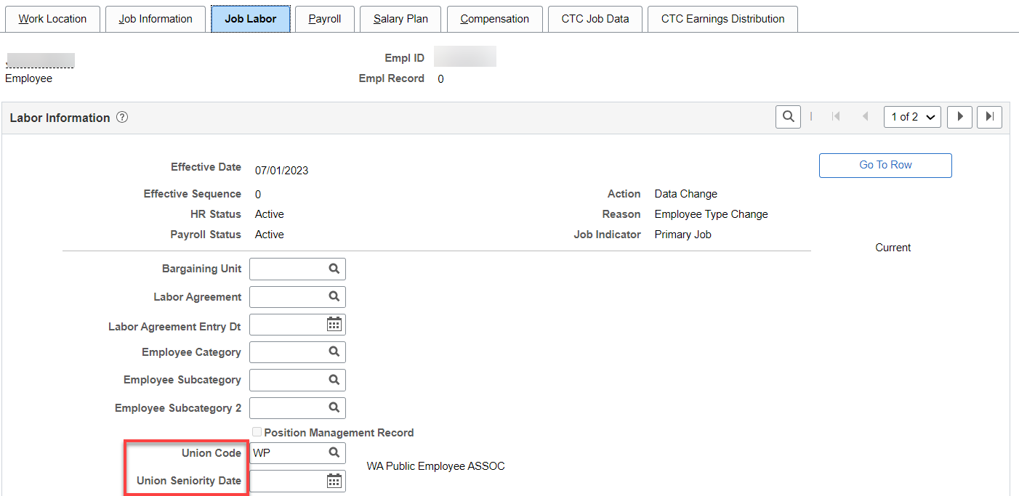

Payroll tab: Add Absence System (Absence Management) and Pay Group. Under Setting, uncheck ‘Use Pay Group Eligibility and add Eligibility Group “XXXNPELIG.”

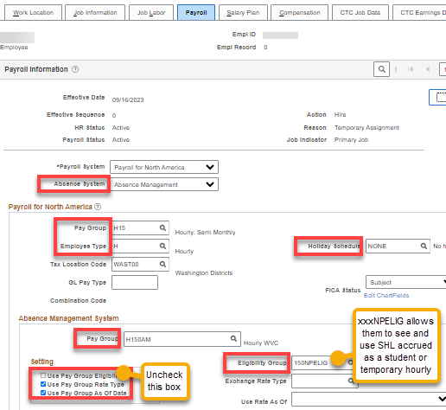

Salary Plan tab: Add Step and Step Entry Date (for 1-15 put the beginning of the month and 16-end of month, the 1st of the following month). Even if the employee starts above step 1 or even at the top step, put in the dates above. The system knows to move them up 6 months, a year or six years. PART TIME NONPERMANENT RECEIVE STEP INCREASES just like other classified

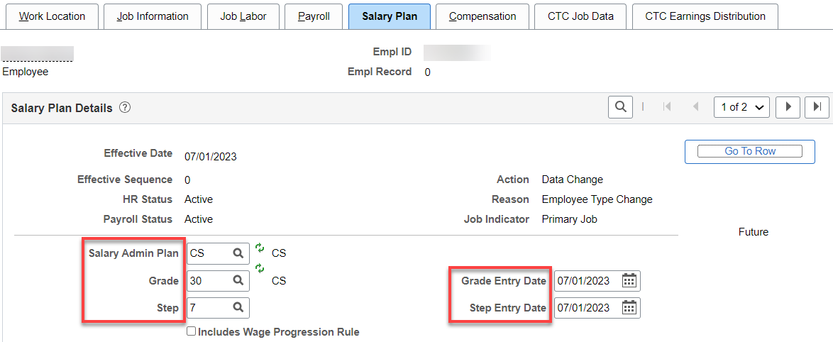
Compensation tab: Select Default Pay Components to add the Pay Components or add manually-Rate Code (NAANL), Comp Rate (Annual), Frequency should be “A” and hit Calculate Compensation. Compensation Rate Frequency should be “H.”

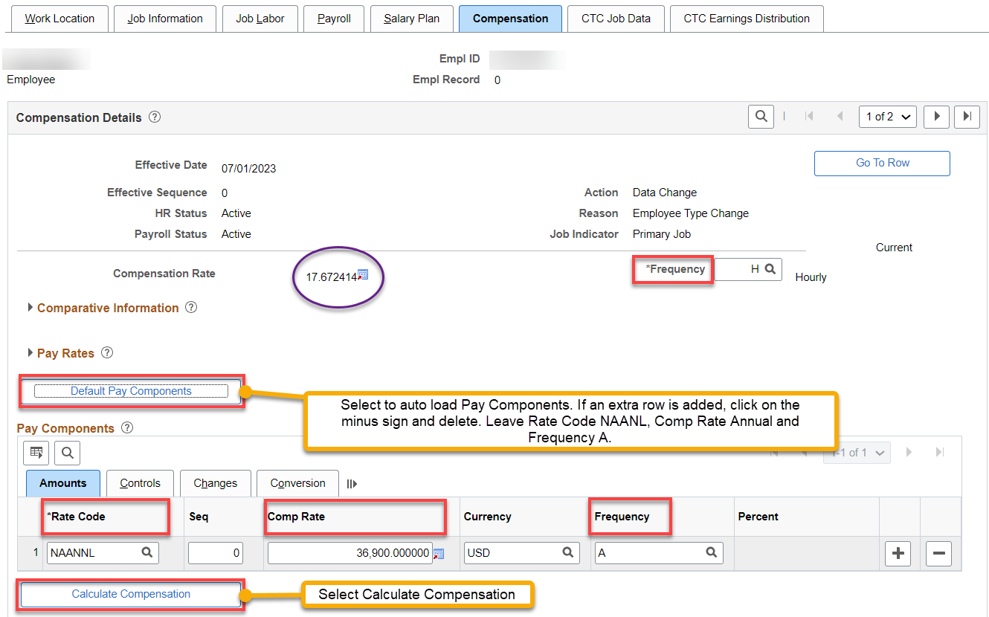

CTC Job Data tab: Add Leave Accrual Date (the first of the current month, Leave Max Month (always the month hired), Job Emp Type, (Non Perm Limited for scheduled and Non Perm On Call for Nonscheduled), check Union Member, if applicable (has nothing to do with union dues…BUT, it’s important for other union-related things like MOUs and union reporting) and OFM Bargaining Unit (if applicable).

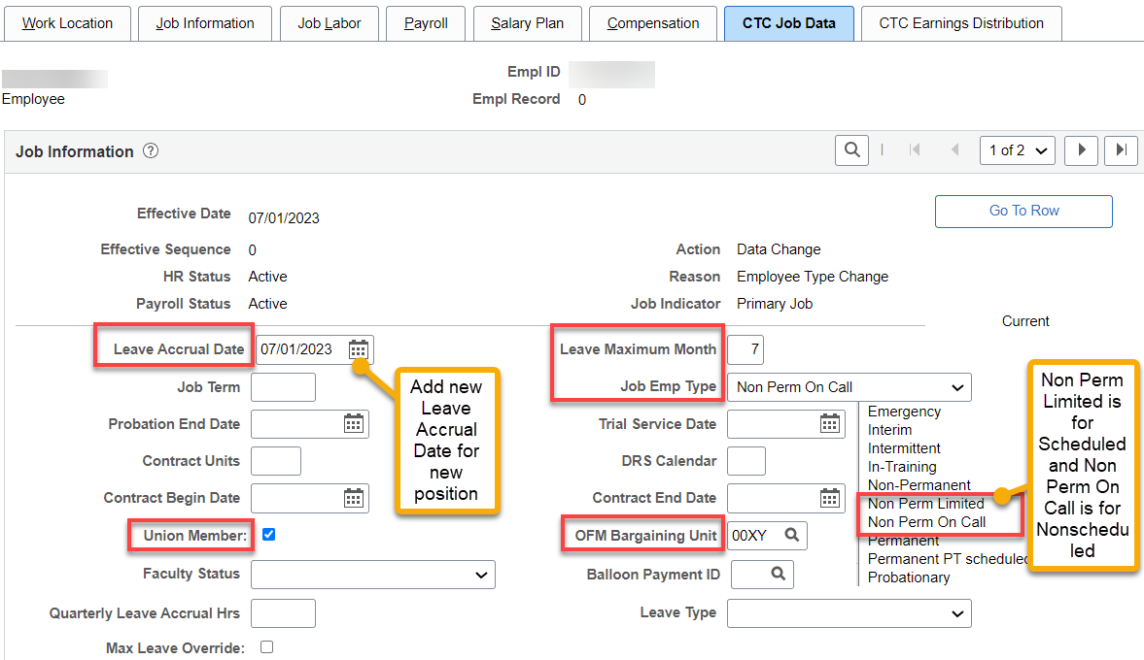

CTC Earnings Distribution tab: Add Earnings Code (HRY), Percent of Distribution, check Primary on all codes (if more than one), click on Edit ChartFields to add Combination Code(s).

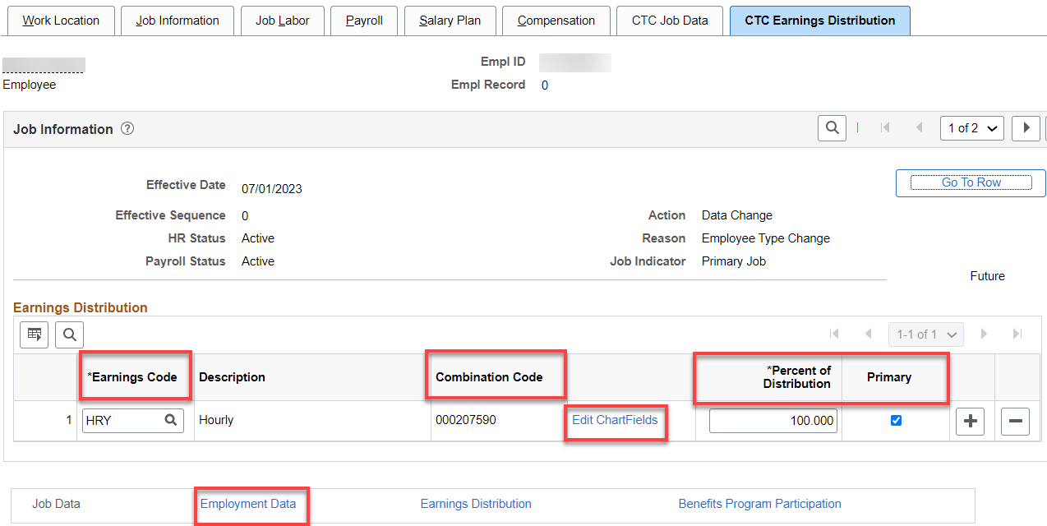

After entering the Combo Code, you can hit the Search button and the ChartField Detail will populate; check budget to see if it matches what you need, click OK.

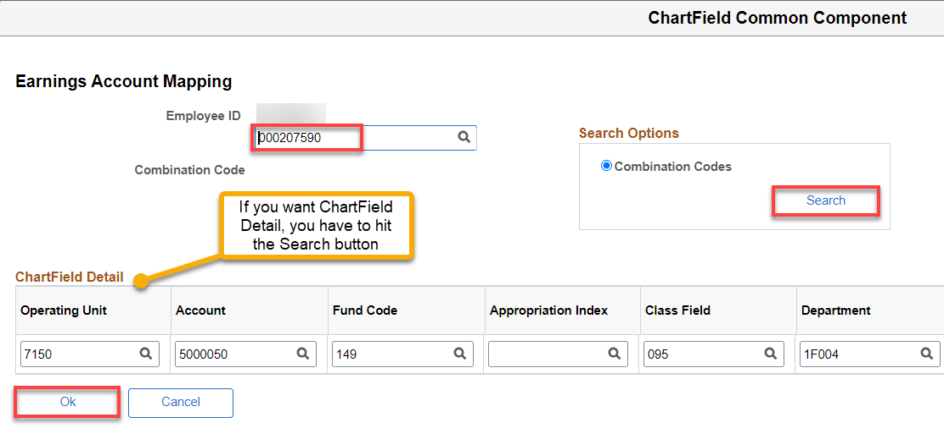

Click on Employment Data Hyperlink (Employment Information will autofill after filling out the Time Reporter Data).

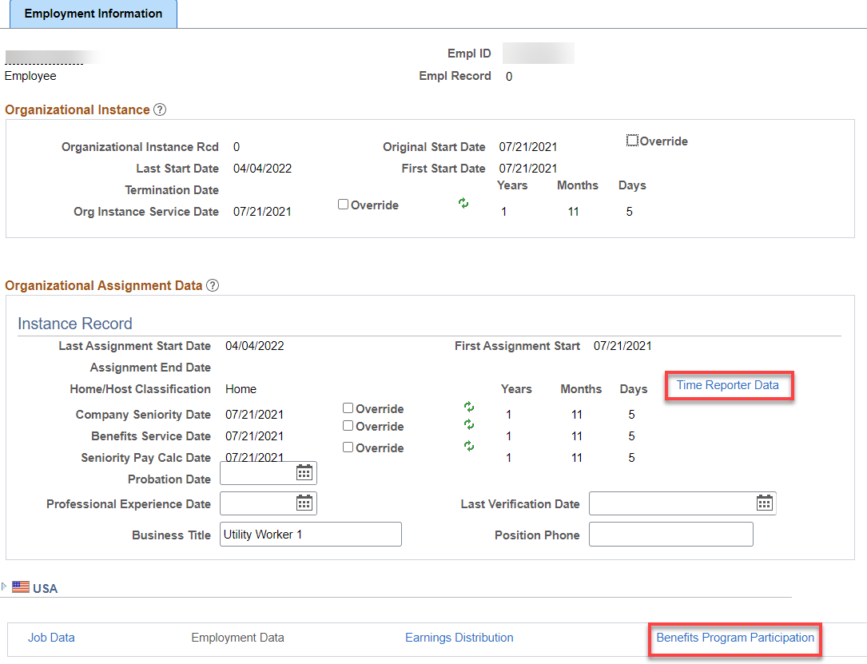

Click on Time Reporter Data First, change the effective date to the hire date, Change Time Reporter Type to Punch Time Reported, Add Punch Time Template, appropriate Workgroup, Taskgroup, click OK.

Note: save yourself a lot of time by putting in the first digits (e.g., 15) in Workgroup, to bring up only the workgroups associated with our college).

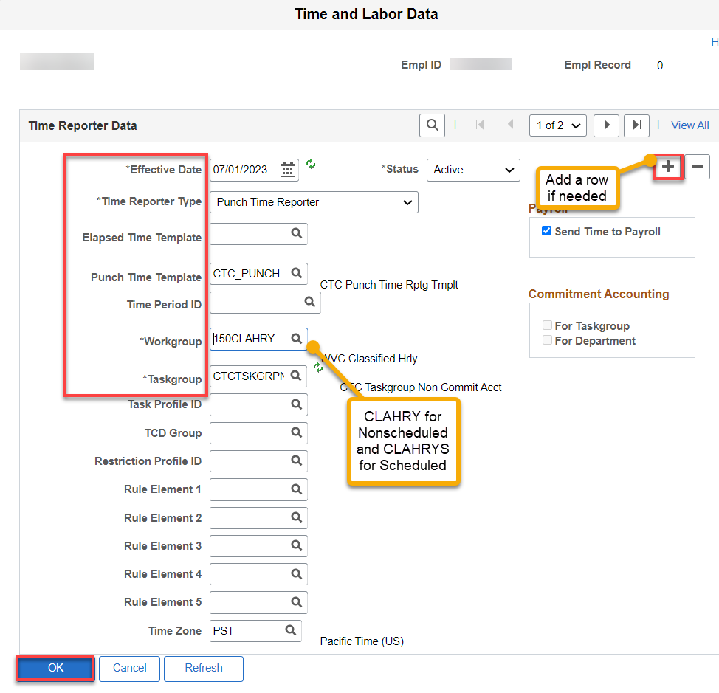

Click on the Benefit Program Participation hyperlink
Add Benefit Record Number and appropriate Benefit Program Participation Details if necessary. If a rehire and the old Benefit Participation Details are present, add + a row and put the updated info in.

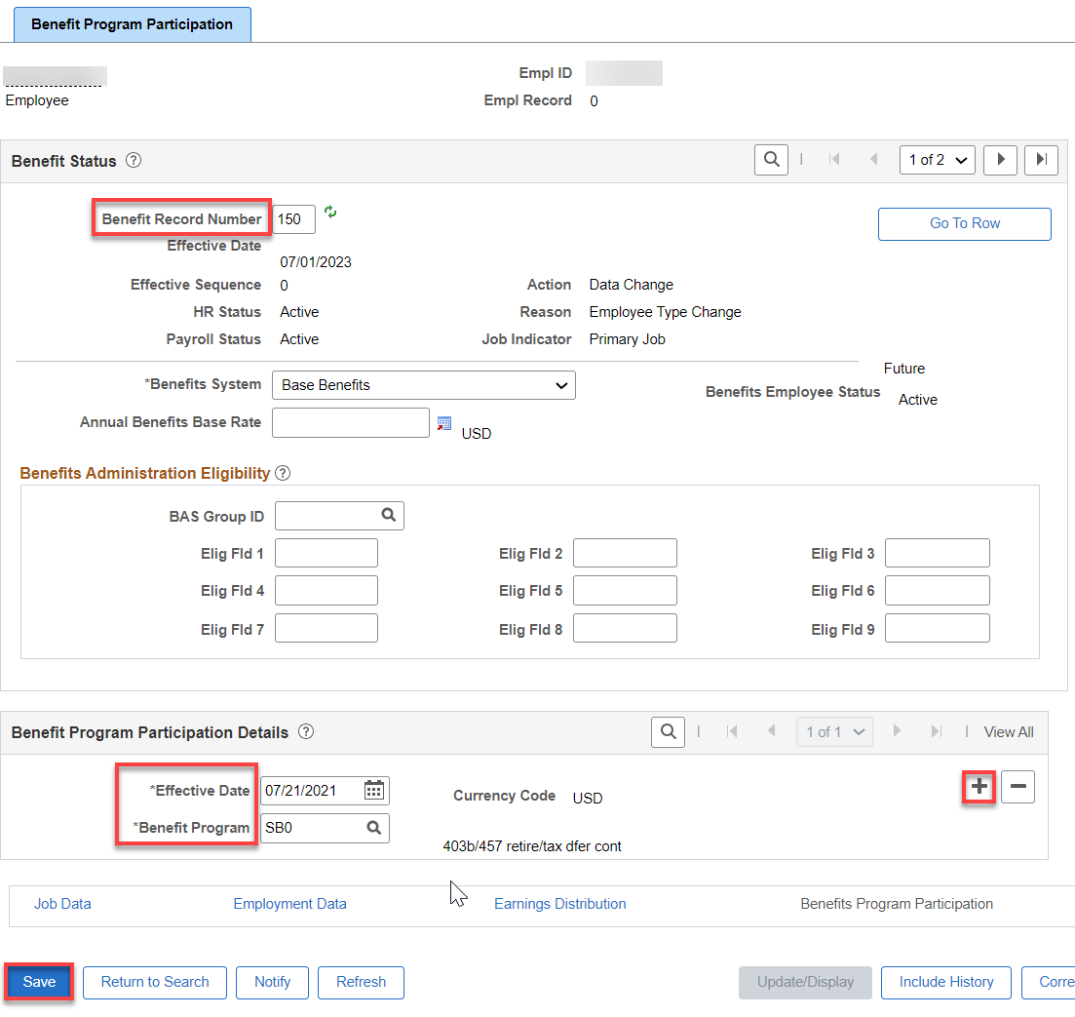
After you click save, you may see a couple of warnings, just read and click ok.

Assign ACA Status – Nav>Benefits>CTC Custom>Assign ACA Status

IF ACA Status has not been assigned, do so. Should be less than 130 hours, effective the 1st of the current month. Add a Row if this is a change. Save.

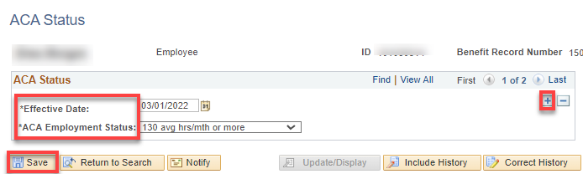

AFTER START DATE
Assign Work Schedule - Nav>Time and Labor>Enroll Time Reporters>Assign Work Schedule OR Workforce Administrator, Time & Labor Admin Tile, Enroll/Maintain TL Data>Assign Work Schedule

In order for leave to accrue and holidays to work correctly, a work schedule must be assigned from Use Default Schedule to Select Predefined Schedule.

Add Effective Date (Start Date), Assignment method (change from Use Default Schedule to Select Predefined Schedule, Schedule Group (WACTC) and the schedule ID (choose 8X7 MTWTHFSSU OR 10x7 MTWTHFSSU). You can see the schedule by clicking on Show Schedule or add a new schedule (in the future) by adding a row.

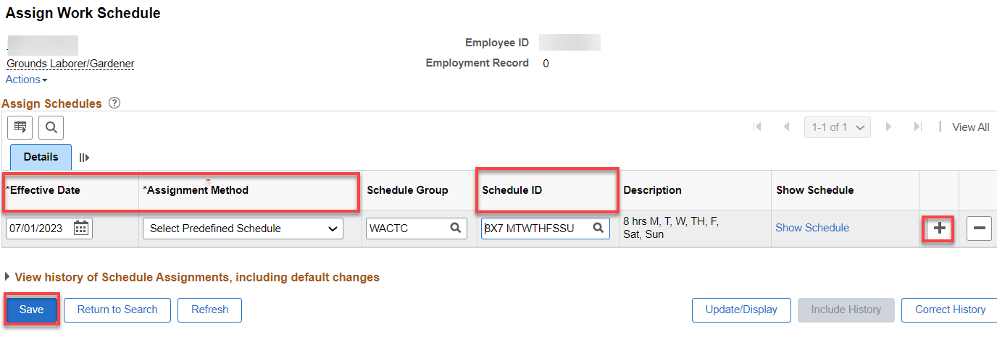

Assign Comp Plan - Nav>Time and Labor>Enroll Time Reporters>Comp Plan Enrollment OR Workforce Administrator, Time & Labor Admin Tile, Enroll/Maintain TL Data>Comp Plan Enrollment.

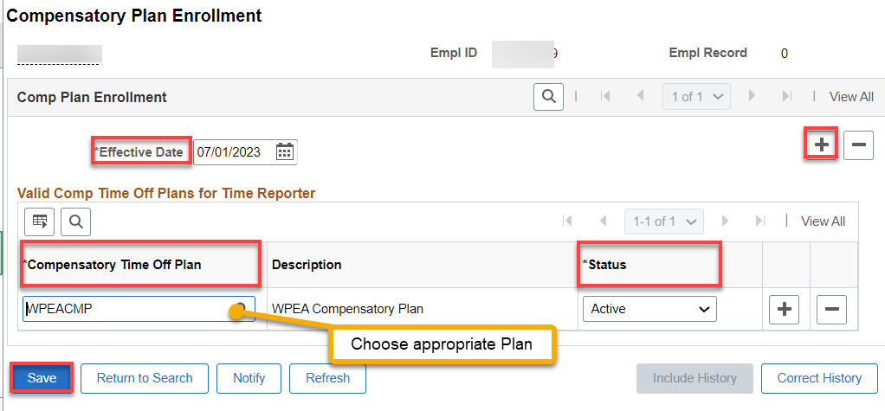
That’s it .

FYI

New TRC codes for Holiday pay have been created.

NPO - Classified Hrly Nonscheduled EE Holiday Pay (Short Description: CH EE HOL) – Usage: Employee gets
Holiday credit, which they request to use in Absence Management. The TRC is mapped to
Absence Management.

HNP - Classified Hrly Scheduled EE Hol Pay (Short Description: CHS EE HOL) - Usage: Scheduled
Employee enters the TRC in Time and Labor. TRC is mapped to HNP earnings code in Payroll.

