Absence Management Process:
1. A Take Process – Identify, calculate phase runs on last day of A Pay period and it will be finalized by 12 noon before Payroll cutoff Day
2. B Take Process – Identify and Calculate Phase runs on the last day of B Pay period and it will be finalized by 12 noon before Payroll cutoff Day
3. ENT process – Identify and Calculate Phase runs after the B Payroll Cutoff Day and finalized before 7 or 8th of the month.
Between Identify and Finalization, College Admin can make changes, Validate the Results and they can request SBCTC Central Payroll Team to do recalculation run. Attached the Absence Process flow Diagram below.
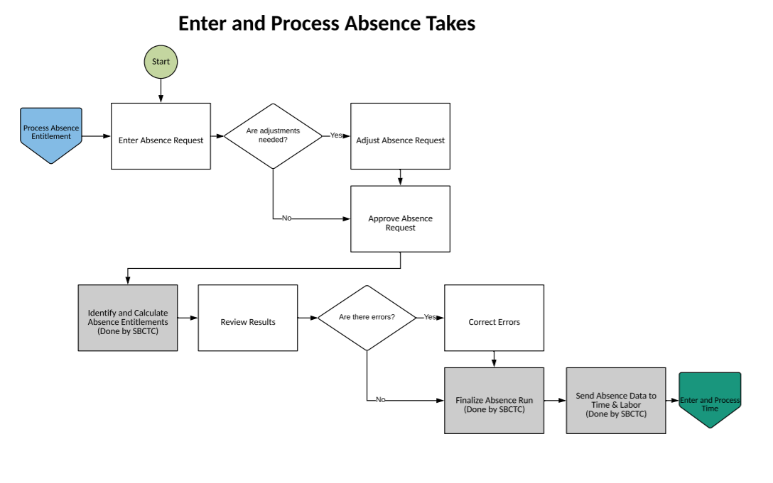
Absence admin can use below queries to validate the Absence data during the Absence run process.
Validation queries for the Take Run:
1. QHC_AB_ABSENCE_HISTORY – Query to find the absence request for the pay period.
2. CTC_Unpaid_leave - Query to find out the unpaid leave report for the Pay period.
3. CTC_Unapprove_ Leave - Query to find out the unapproved leave request for the month
Validation queries for the ENT Run:
QHC_AB_VALIDATION_ENT_CAL_RUN – Query to find out the accrual for the month and balance after the accrual run.

Central Payroll Team has updated the Absence schedule Dates on the SBCTC calendar.
URL for SBCTC Calendar - Absence process calendar

Absence Management
The first month with have the following Absence Runs:
Absence Take processing for A Payroll (Period 01st of month till 15th of month).
- Make sure that all the employees put their leave request in the ctcLink PeopleSoft system for all leaves taken from 01st of month till 15th of month.
- All the leave requests for this period should be approved by their supervisors.
- As a back-up, the Leave Administrators can also enter the Absence request and Approve absence requests on behalf of the approvers.
- Only the approved Absence requests will be processed by the Absence process and sent to payroll.
- The Administrators need to validate the Absence data after the SBCTC Central Payroll Team runs the Absence process. (Absence Validation is done in the Results by Calendar Group page Absence Tab). QRG: Using Results by Calendar Group
- Run the Unpaid Leave report to make sure you review all the leaves which are unpaid because the employee DOES NOT have sufficient leave balance.
- Make sure all the Absence take validations are completed prior to the Payroll cut-off date for finalizing the Absence run. The SBCTC Central Payroll team is responsible for finalizing the Absence run and pushing the Absence data to Payroll.

Absence Take processing for B Payroll (Period 16th of the month till 31st or last day of month).

- Make sure that all the employees put their leave request in the ctcLink PeopleSoft system for all leaves taken from 16th of the month till 31st or last day of the month.
- All the leave requests for this period should be approved by their supervisors.
- As a back-up the Leave Administrators can also enter the Absence request and Approve absence requests on behalf of the approvers.
- Only the approved Absence requests will be processed by the Absence process and sent to Payroll.
- The Administrators need to validate the Absence data after the SBCTC Central Payroll team runs the Absence process. (Absence Validation is done in the Results by Calendar Group page Absence Tab).
- Run the Unpaid Leave report to make sure you review all the leaves which are unpaid because the employee DOES NOT have sufficient leave balance.
- Make sure all the Absence take validations are completed prior to the Payroll cut-off date for finalizing the Absence run. The SBCTC Central Payroll team is responsible for finalizing the Absence run and pushing the Absence data to Payroll.

Absence Accrual/Entitlement processing for month end (Period 01st of the month till 31st or last day of the month).

- Leave Accrual/Entitlement process is not linked to any payroll run. This is a separate process which is run after the B payroll run every month.
- The Administrators need to validate the Absence data after the SBCTC Central Payroll team runs the Absence process. (Absence Validation is done in the Results by Calendar Group page).
- Review all the different classification of employees and make sure all the employees are getting their leave accruals correctly. Validate at least a couple of employees from each employee classification.
- Make sure all the Absence accruals validations are completed prior to the cut-off date for finalizing the Absence Entitlement run. The SBCTC Central Payroll team is responsible for finalizing the Absence Entitlement run.
- The Absence accrual data updates the Absence Balances for all the employees and does not need to be sent to payroll.

