Adjusting Multi-Segment Leave Accrual

Note: there is a 90-day maximum retroactive processing period.

The purpose of this document is to help me remember what to do when we run the following query and find employee(s) that are accruing leave for both the first and second half of a month (double accrual). This happens from time to time when an employee goes from one job to another during the month, etc.

QHC_AB_VALIDATION_ENT_MULTISEG - Query to find multiple Segment in accrual run. (Double Accrual) RUN THIS because several actions cause a new segment which may cause another accrual

The following is a good example:

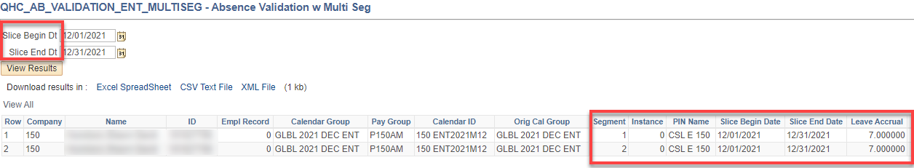

View the leave accrual in “Results by Calendar Group Page”. After Absence finalization, view the Leave Balance in “Review Absence Balance” Page.

The Segment accrual date must match adjustment dates (Slice Begin and End Dates). The example above did work but it’s not ideal.

When adjusting leave balance for one of the segments, use the accrual dates for the segment being adjusted, i.e., 12/1 – 12/15 for segment 1 or 12/16 to 12/31 for segment 2.

That’s it!

