**Putting in a Leave Request (Absence Request) (good to copy and paste into an email)**

Some of you have never put in a leave request (now known as an absence request), so I hope this is helpful. AND, if you have never put in a partial request (less than your scheduled shift) or you have tried to put in leave for less than a full day, you have probably felt…well…a little frustrated with ctcLink. The process IS NOT intuitive, meaning *it’s difficult* until you know how and then it’s still difficult. 😊

Here is the process (with pictures):

**Go to Employee Self Service**

**cid:image007.png@01D757C2.FE19E1E0**

**Click on the Time Tile**

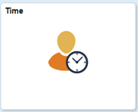

**Click on Request Absence Tile**

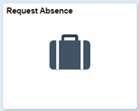

**Once you are in Request Absence, select the absence name (if you don’t know what to choose, contact HR and we will help).**

cid:image011.png@01D757C2.FE19E1E0

**After choosing the leave type, choose the start and end date. You can choose multiple days *only* if they are regular shift hours. If the hours vary or between work weeks, put in separate requests. This is especially true for partial requests (see below).**

**You can put in a comment if you choose but it is not required.**

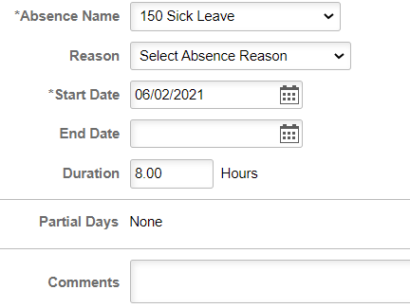

**Once you are finished, click the Submit button on the top right of the screen.**

cid:image017.png@01D757C2.FE19E1E0

**That’s it…unless you need to put in a partial day. If that’s the case then *hang on* and follow these 14 easy steps.**

**First, click on the words “Partial Days.” It’s a hot link even though it’s not underlined (actually the whole row is the link). The following box opens up:**

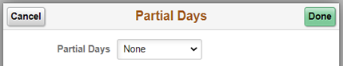

**Click on “Partial days” then click on Start Day Only or All days (it doesn’t matter)**

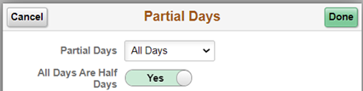

**If it is a half day, then click Done and Submit. If it’s not a half day, then click the green highlighted Yes and it will change to NO and put in the number of hours. Click Done and Submit.**

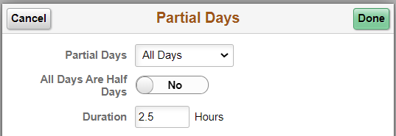

**That’s it! Now wasn’t that fun? 😊**