Absence Event Approval by Administrator (HR)

Workforce Administrator>Absence Administration Tile>Absence Event.

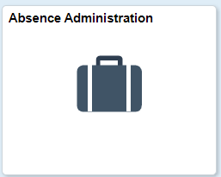

1. Enter the Employee ID.

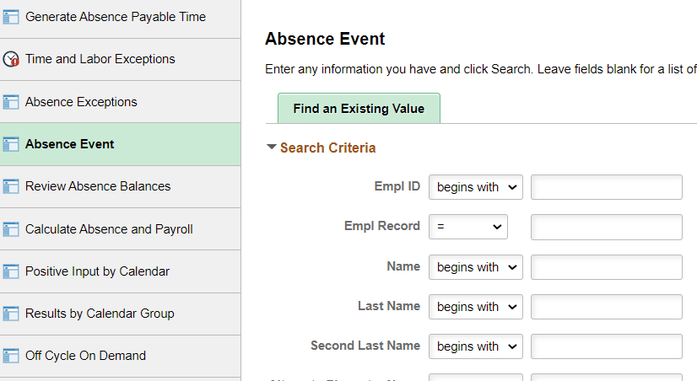

2. Select the details Link.

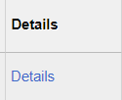

3. Click Manager Approved

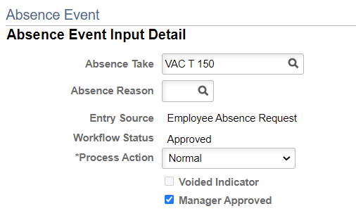

4. Click OK.

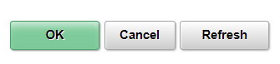
5. Click Save.

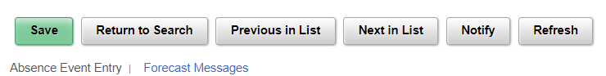

That’s it!

