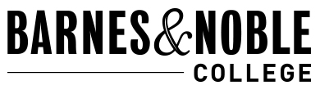
Online Buyback
- Go to wvc.bncollege.com
- Scroll down the page until you see the following:
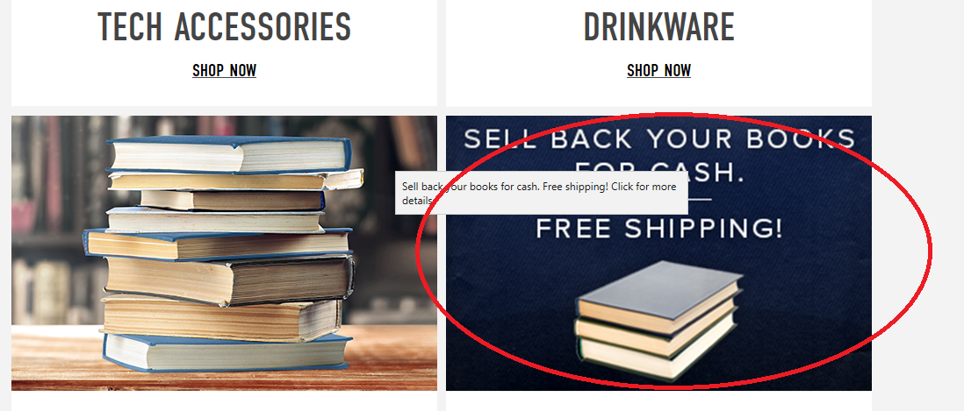

- Enter the Book ISBN: This is the number on the barcode on the back usually beginning with 978….
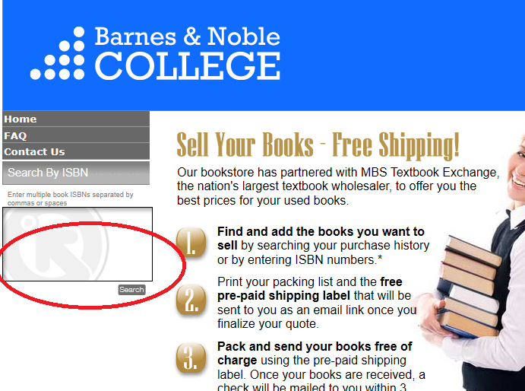
.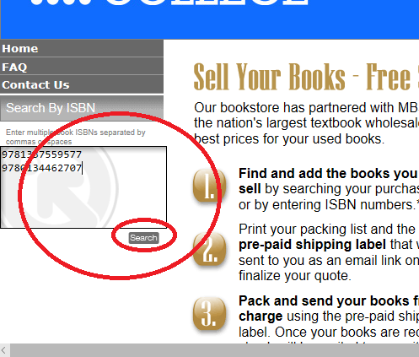

- Note that some books do not qualify as this is a “Wholesale Buyback” We will be open for retail buyback once things return to normal.
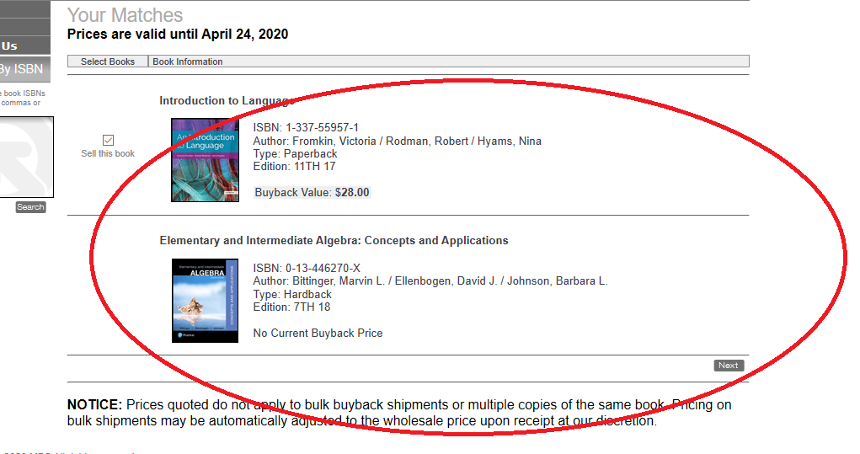
- You can select to be paid by check or by Pay pal. Please read all the notices for allotted times.

